Curriculum Vitae (CV)

Title | Ms | First Name | Renu | Last Name |  | Mehta | Photograph
Designation |  | Associate Professor |  |  |  |  | 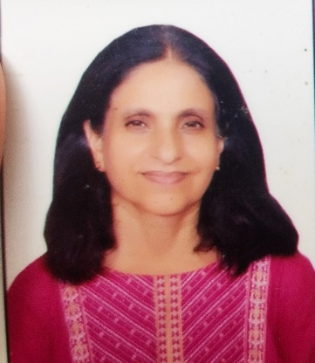
Department |  | English
Address  (Campus) |  | SPM College  Road no 57, North Avenue  Punjabi Bagh West  New Delhi 110026
Phone Number(Campus) |  | 011-25224499
Fax
Email |  | renumehta@spm.du.ac.in
Education
Subject |  | Institution |  |  | Details
English |  | Delhi University |  |  | M.Phil (1996)
English |  | Miranda House, DU |  |  | MA (1993)
English |  | Miranda House |  |  | BA hons (1991)
Research Interests/ Specialization
Post- Colonial Literatures, Nineteenth Century European Realism, Indian Writing in English

Teaching Experience
1993 to the present
Courses taught: Indian Writing in English, Post Colonial Literatures, Women’s Writing, American Literature, Nineteenth Century European realism
Participation in International Conferences/Workshops:
National Seminar on Building Sustainable Future for Youth JIMS Presented a paper titled Gender Sensitization: Need of the Hour
“Interdisciplinary Crossings in English Studies: Theory, Research and Classroom Practices” organized by CPDHE. Presented a paper titled: A Study of Achebe’s treatment of History in The African Trilogy
“Women Studies” Organized by Women’s Studies and Development Centre. Presented a paper titled: A Study of Rassundari Debi’s Amar Jiban

Other Responsibilities: Teacher in charge, Department of English, Convenor: Magazine committee, Women Development Cell, FCC, Workload committee.
Member: IQAC, Cultural committee

